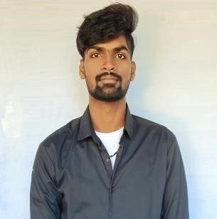
Aswin M
Mobile No: 9344367446
Email : aswin23022003@gmail.com
LinkedIn id : https://www.linkedin.com/in/aswin-m-a53b97252
OBJECTIVE
To work in an environment that challenges me to improve and constantly thrive for perfection in all the tasks allotted to me.
EDUCATIONAL QUALIFICATION
QUALIFICATION | YEAR OF PASSING | INSTITUTION | PERCENTAGE
BE - CSE | 2024 | Dr.Sivanthi Aditanar College of Engineering | CGPA: 8.47
HSC | 2020 | Evans Matriculation Higher Secondary School | 72.8%
CBSE | 2018 | Gnana Vidya Mandir CBSE School | 62.6%
COURCES
- UI / UX Design

PROJECT
- ANPR – Automatic Number Plate Recognition
*Image Processing

- Automatic Number Plate Recognition (ANPR) is a popular application of computer vision that involves identifying and reading the license plates of vehicles from images or video feeds. ANPR can be implemented using various machine learning algorithms, including Support Vector Machines (SVM) and Active Contour.
- FUEL FINDER
*Dijkstra’s Algorithm

- Fuel Finder is a Mobile Application designed to process of locating the nearest petrol pump for drivers. Dijkstra’s Algorithm , the app calculates the shortest path from the user’s current location to nearby petrol pumps.

AREA OF INTEREST
- Software Development
- Frontend Developer
- Web Designing
- Programming
- Technical Documentation

TECHNICAL SKILLS
- UI & UX
- HTML/CSS
- Javascript
- MS Excel Basics
- C Programming basics
CERTIFICATION
- UI UX Figma Essential
WORKSHOP
- One – day Workshop On Machine Learning Using Java
STRENGTH
- Willing to face new Challenges
- Fast to learn new technologies
- Self-motivated easily adaptable to new environment
- Highly organized and dedicated with a positive attitude
- Challenges to accept in new environment
HOBBIES
- Drawing
- Painting
- Travelling
- Photography

AWARDS
- 2015 - Achieved Silver Medal in district Level Silambam Competition
- 2015 - Achieved Bronze Medal in district Level Silambam Competition
- 2016 - Achieved Gold Medal in district Level Silambam Competition
PERSONAL INFORMATION
Father’s Name | : Murugan C
Mother’s Name | : Vasanthi M
Date of Birth | : 23.02.2003
Marital Status | : Single
Address | : 20/53, Mela Kattu Vilai, Mani Ketti Pottal Post, Nagercoil – 629501
Languages known | : Tamil , English
DECLARATION
I hereby declare the furnished above information are true to the best of my knowledge and bear the responsibility for the correctness of mentioned particulars .

Place:  Date: | [ASWIN M]

